Task2

**Cars**

--Select

select * from Cars;

select * from Cars where CustomerId = 0 OR model = 'model1';

select Id,TotalCost from Cars where CustomerId = 0 order by TotalCost;

select * from Cars where CustomerId = 0 OR model = 'model1' order by TotalCost desc;

select * from Cars where CustomerId = 0 OR model = 'model1' and TotalCost between 20000 and 30000 order by TotalCost;

select Min(TotalCost) from Cars;

select max(TotalCost) from Cars;

select avg(TotalCost) from Cars;

select sum(TotalCost) from Cars;

select count(model) from Cars where Status = 'active';

select top 3 * from Cars;

select top 70 percent Id,Status from Cars where Status = 'active';

--Insert

insert into Cars values(3,0,0,'modelnew','active',23900);

insert into Cars values(4,0,0,'modelnew1','active',12000),(5,0,0,'modelnew1','active',1200),(7,0,0,'modelnew1','active',15698);

insert into Cars(Id,CustomerId,EmployeeId,Model,Status,TotalCost) values (8,1,2,'modelnew2','active',10977);

--Update

UPDATE Cars SET CustomerId = 2, Model = 'Update1' WHERE Id = 8;

UPDATE Cars SET CustomerId = 2, Model = 'Update2' WHERE EmployeeId = 0 and model = 'model1' and TotalCost >20000;

UPDATE Cars SET Status = 'unactive', Model = 'Update3' WHERE TotalCost > 20000 and TotalCost < 30000;

--delete

delete top(3) from Cars where TotalCost <= 10000 and Status = 'active';

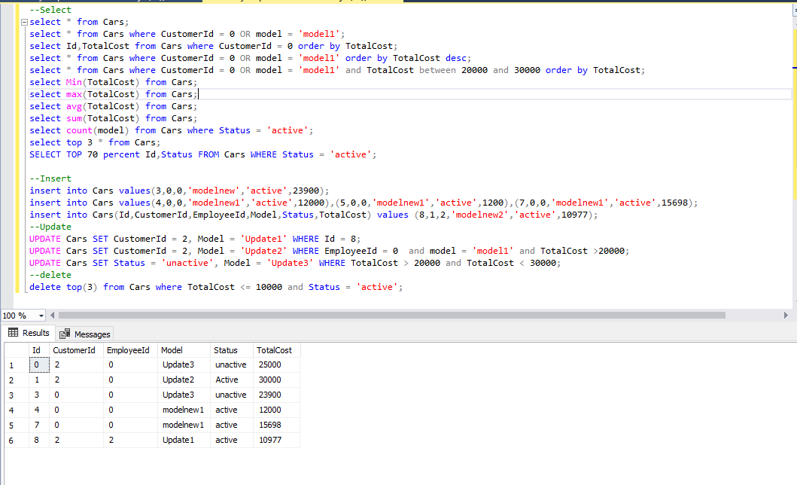

**Customer**

--Select

select * from Customer;

select * from Customer where Not( Email like 'sma%' And PhoneNumber like '079%');

select Id,PhoneNumber from Customer where PhoneNumber like '%2_' order by PhoneNumber;

select * from Customer where Email like '%gmail%' OR PerformanceContact = '' order by PhoneNumber desc;

select top 8 * from Customer;

SELECT TOP 20 percent Id,FName,LName FROM Customer WHERE PerformanceContact = 'M';

--Insert

insert into Customer values(3,'Asad','OSama','Email@gmail.com','0775634978','M');

insert into Customer values(4,'Asad','OSama','Email@gmail.com','0775634978','M'),(5,'Ahmad','Oama','Ahmad265@gmail.com','07877653345','M');

insert into Customer(Id,FName,LName,Email,PhoneNumber,PerformanceContact) values (7,'FName','LName','Email@gmail.com','0000000000','M');

--Update

UPDATE Customer SET PerformanceContact = 'P' WHERE PerformanceContact = 'M';

UPDATE Customer SET PhoneNumber = '0', Email = 'Email' WHERE PhoneNumber like '079%' and Email like 'sma%';

--delete

delete from Cars where CustomerId = 2;

delete from Customer where Id = 2;

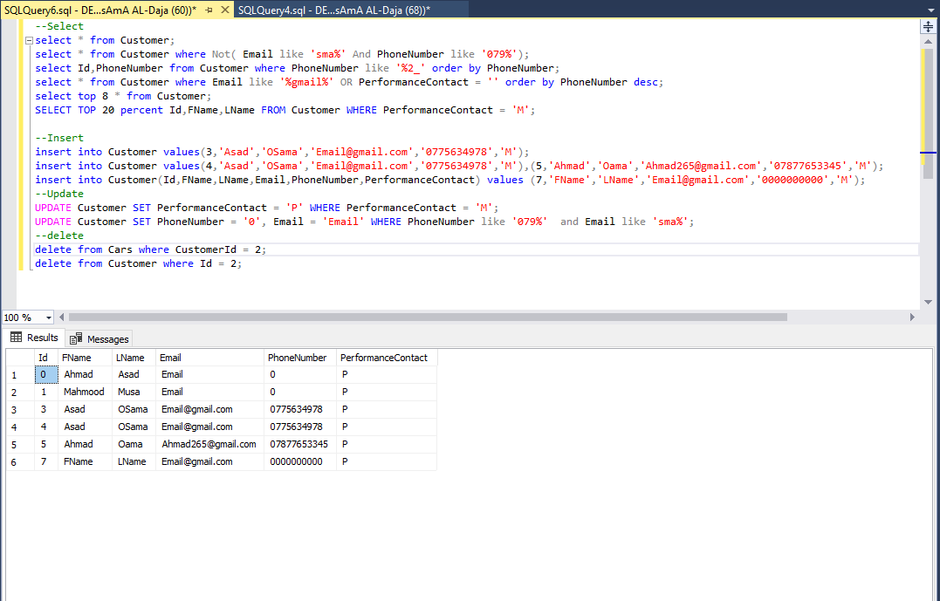

--Select

**Departments**

select * from Departments;

select Name from Departments where Id >1 order by Id;

--Insert

insert into Departments values(3,'Flutter');

--Update

UPDATE Departments SET Name = 'Asp.net MVC5' WHERE Id = 2;

--delete

delete from Departments where Id = 3;

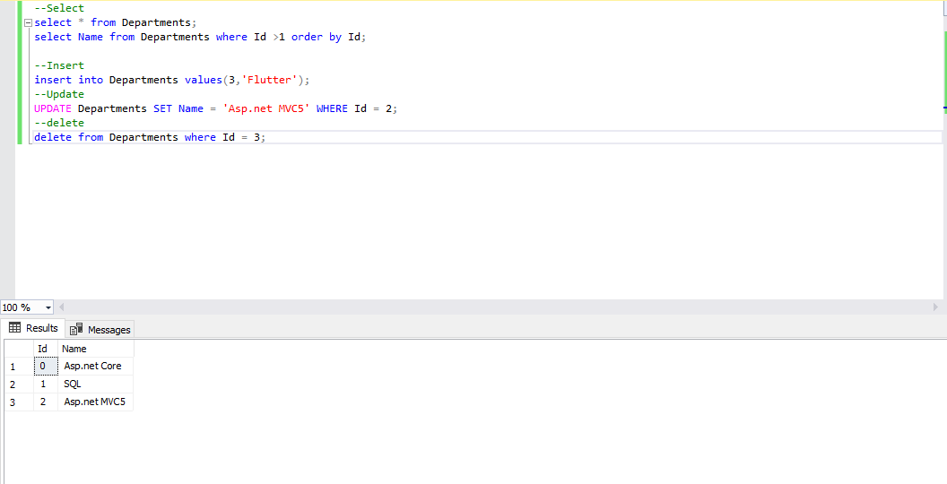

**Employees**

--Select

select * from Employees;

select * from Employees where GenderID = 0;

select Id,Salary from Employees where Salary between 500 and 1000 order by HireDate;

select * from Employees where HireDate between '2020-1-1' and '2022-1-1' OR Salary between 500 and 1000 order by Salary desc;

select * from Employees where DepartmentId = 0 and Salary between 500 and 1000 order by HireDate;

select Min(Salary) from Employees;

select max(Salary) from Employees;

select avg(Salary) from Employees;

select sum(Salary) from Employees;

select count(Salary) from Employees where HireDate between '2020-1-1' and '2022-1-1';

select top 3 * from Employees;

SELECT TOP 70 percent Id,FName,LName,PhoneNumber FROM Employees WHERE ManageId = 0;

--Insert

insert into Employees values(4,0,0,'modelnew1','active',12000),(5,0,0,'modelnew1','active',1200),(7,0,0,'modelnew1','active',15698);

--Update

UPDATE Employees SET ManageId = 1 WHERE Id = 1;

UPDATE Employees SET Salary = 900 WHERE Salary <=800 and HireDate between '2020-1-1' and '2022-1-1';

--delete

delete from Employees where Id = 2;

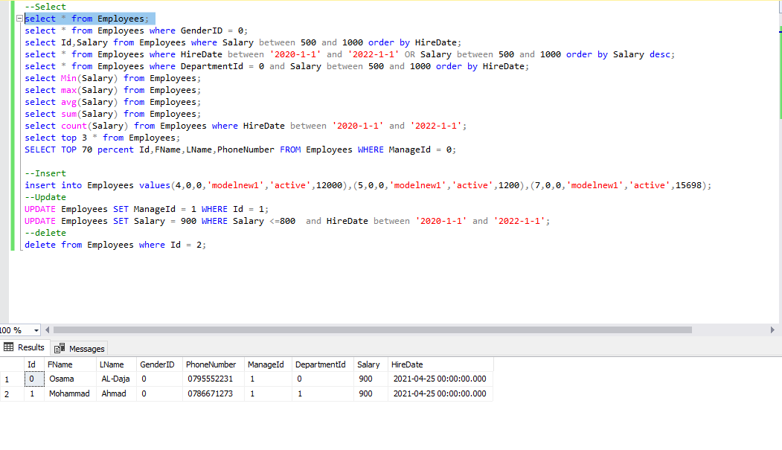

**Gender**

--Select

select * from Gender;

select GenderTitle from Gender;

--Insert

insert into Gender values(4,'Gender');

--Update

UPDATE Gender SET GenderTitle = 'Update' WHERE GenderID = 4;

--delete

delete from Gender where GenderID = 4;

